Exploring weather trends

Data Extraction:

1. Finding the nearest city to mine “Dammam, Eastern province” in Saudi Arabia:

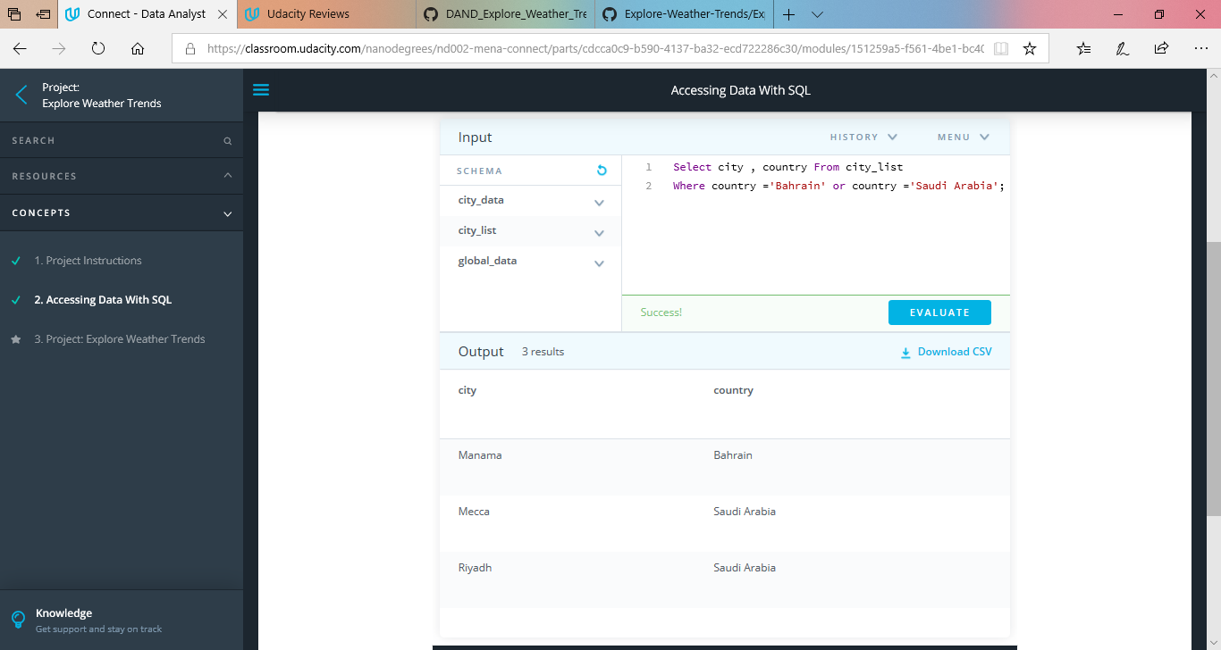

In this case “Manama, Bahrain” is the nearest.

1. Extract the global temperature data

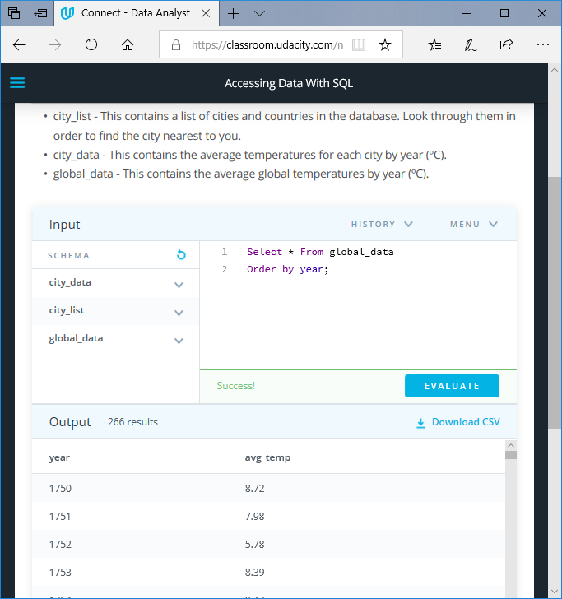

1. Extract city temperature data

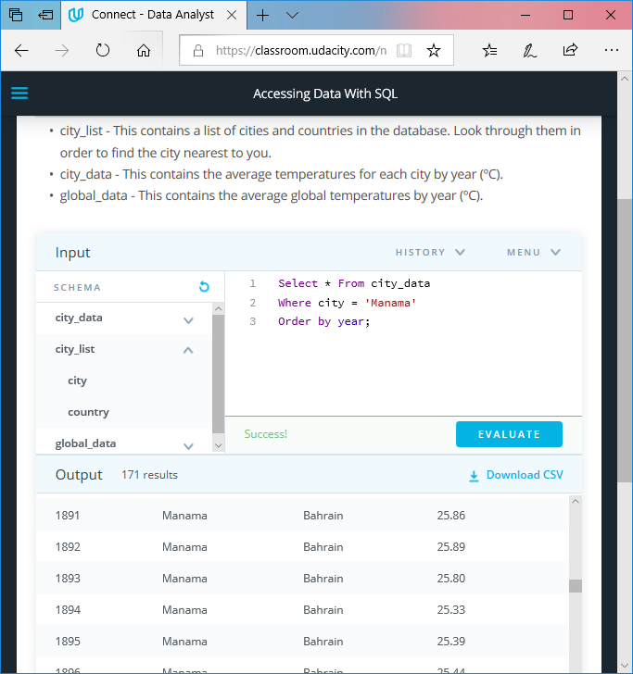

Data Manipulation:

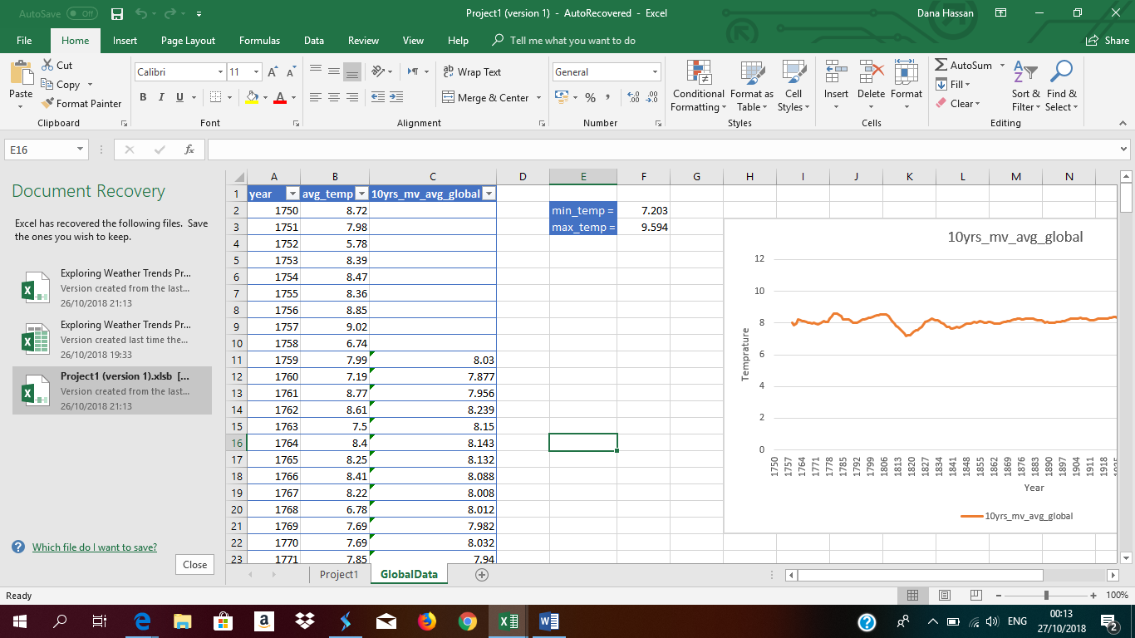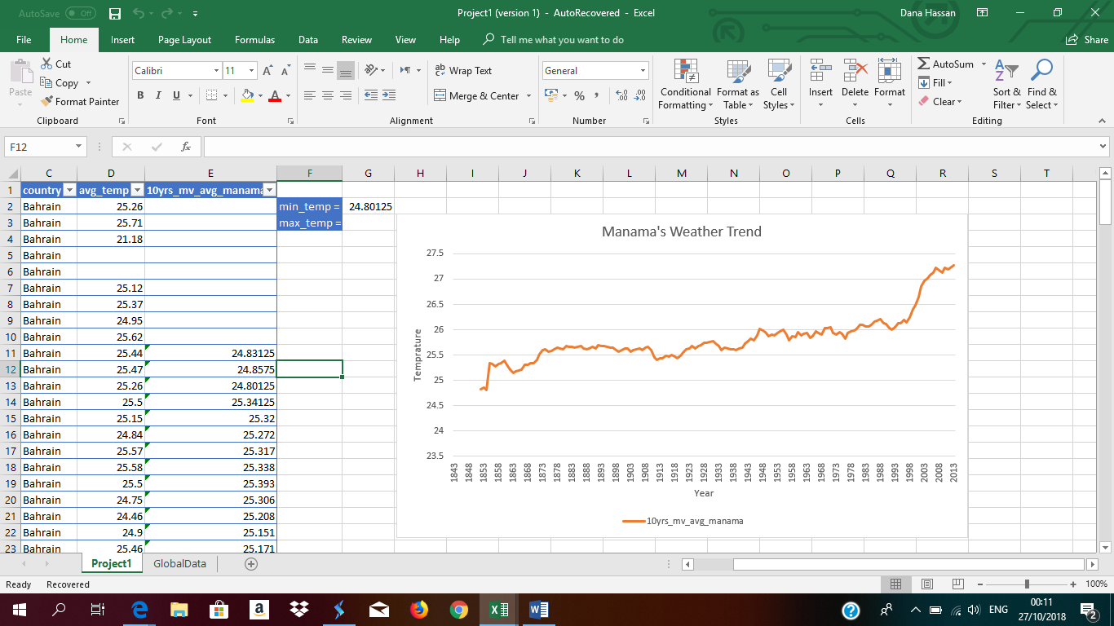In order calculate the 10 years moving average for Manama city and the globe, I used the average function in excel.

Data Visualization:

The plot below shows the moving average for the globe

The moving average for Manama city

Data interpretation:

For the globe weather trend:

The chart shows global trend that Global average temperature is increasing over the years. (Hotter weather)

The minimum recorded temperature is 5.78, recorded in 1752.

The maximum recorded temperature is 9.83, recorded in 2015.

For Manama’s weather trend:

The chart shows that Manama’s average temprature is increasing over the years. (Hotter weather)

The minimum recorded temperature is 21.18 recorded in 1845.

The maximum recorded temperature is 28, recorded in 2010.

The weather is getting hotter over the years in Manama and the Globe.